# Lab: Text Processing

## Print Characters

Write a function that **receives a** **string** and **prints all the** **characters** on separate lines.

### Input / Output

|  |  |
| --- | --- |
| **Input** | **Output** |
| 'AWord' | A  W  o  r  d |

### Hints

Loop through the string and print each character.

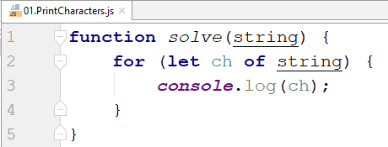

## Remove Occurrences

Write a function that receives a **text** and a **word** to remove **all occurrences** of it inside the text.

### Input / Output

|  |  |
| --- | --- |
| **Input** | **Output** |
| ice  kicegiciceeb | kgb |

### Hints

Replace the occurrence of the word inside a **while loop** and use **replace().**

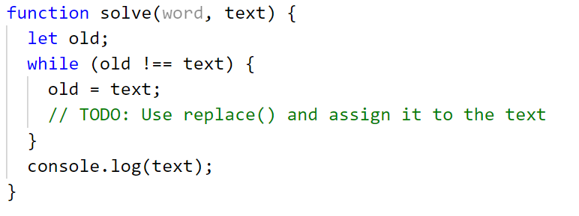

## Substring

Write a function that **receives a string** and **two numbers**. The numbers will be a **starting index** and **count** of elements to substring. Print the result.

### Input / Output

|  |  |
| --- | --- |
| **Input** | **Output** |
| "ASentance", 1, 8 | Sentance |

### Hints

Create a new string that takes the needed amount of elements from the given string.

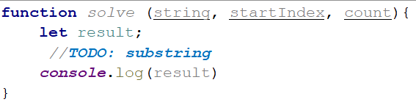

## Censored Words

Write a function that **receives a text as** a first parameter and a **single word** as a second. Find **all occurrences** of that word in the text and replace them with the corresponding count of '*'.

### Input / Output

|  |  |
| --- | --- |
| **Input** | **Output** |
| "A small sentence with some words", "small" | A ***** sentence with some words |

### Hints

Save the new text in a new variable.

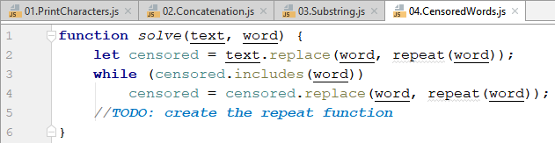

The repeat() function should take the length of the word and return that amount of stars '*'.

## Count String Occurrences

Write a function that **receives a text** and a **string that you need to search**. Print all the occurrences of that word in the string.

### Input / Output

|  |  |
| --- | --- |
| **Input** | **Output** |
| "This is a word and it also is a sentence",  "is" | 2 |

### Hints

Split the sentence into words and create a **counter** that stores how many times the searched word occurs.

